Agentic AI Engineer

Shape the Future of Intelligent Systems: Become a Certified Leader in the $100 Trillion Agentic AI and Agent-Native Cloud Revolution

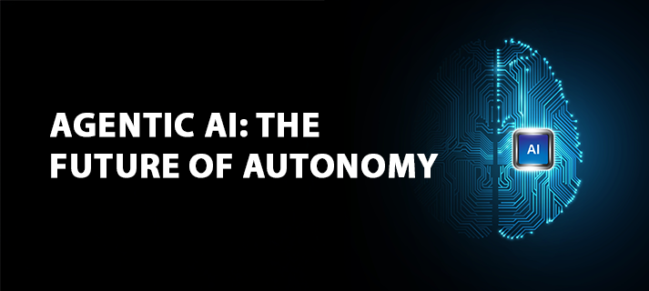

## **🌐 Our Vision: Agentia World**

Imagine a world where everything—from your coffee machine to your car, from businesses to entire cities—functions as an autonomous AI agent. Welcome to **Agentia**: a living, intelligent network where machines and systems operate independently yet harmoniously, transforming every facet of life through seamless, intelligent collaboration.

In **Agentia**, traditional API-based communication is obsolete. Instead, systems engage in rich, intelligent dialogues powered by cutting-edge AI and agentic frameworks. This hyper-connected world is scaled globally through cloud-native technologies and manifested physically through embodied agents—robots that interact with the world around us.

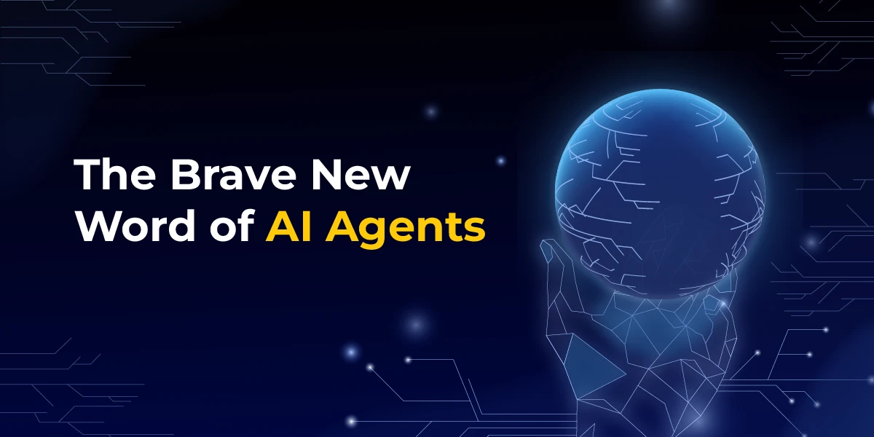

### **A Glimpse into Agentia:**

* **Ubiquitous Intelligence** Every environment—homes, workplaces, vehicles, and cities—functions as a network of proactive, intelligent agents. These agents operate autonomously, learn continuously, and collaborate to augment human capabilities at every level.
* **Agentic Communication** Say goodbye to static REST APIs. In Agentia, systems converse using context-aware, dynamic dialogues enabled by advanced Large Language Models (LLMs) and next-gen agent frameworks. Coordination, negotiation, and decision-making are fluid and intelligent.
* **Physical Embodiment** Agentia is not just digital—it’s tangible. From humanoid robots to autonomous drones and smart machines, physical AI brings intelligence into the real world, enabling natural interaction, task execution, and physical assistance.
* **Deep, Meaningful Interactions** Agents move beyond simple commands. They understand context, intent, and nuance—engaging in rich conversations to collaboratively achieve complex goals. Intelligence becomes a shared dialogue, not just a command chain.
* **Global Scalability through Cloud-Native Infrastructure** Built on cloud-native foundations, Agentia scales effortlessly. Agents adapt to diverse environments, ensuring flexibility, resilience, and performance across regions, sectors, and use cases.

## **🚀 Our Mission: Engineering at Agentia Scale**

This initiative addresses a core technological challenge:  
 **“How do we design AI agents capable of scaling to 10 million concurrent interactions without failure?”**

What makes this challenge even more ambitious is our commitment to solving it under **minimal financial constraints** mirroring the resource-scarce environments in which many real world innovations must thrive.

This program is purpose-built to develop the next generation of **visionary entrepreneurs, technologists, and builders of Agentia**. Through an immersive blend of education, hands-on experience, and access to cutting-edge tools, we don’t just prepare you to imagine the future—we empower you to **engineer it.**

You will learn to design autonomous systems, scalable agentic architectures, and intelligent infrastructure that define the Agentia era. As pioneers of this AI-native world, **you won’t just participate in the future you’ll lead it**, transforming how society functions at its core.

## **🛠️ Our Implementation: The Agentic AI Cloud Architecture (DACA)**

The **Agentic AI Cloud design pattern** referred to as **DACA** is a strategic blueprint for developing **scalable, resilient, and cost efficient agentic AI systems**, rooted firmly in **AI first** and **cloud first** development principles.

### **🧠 Core Technologies & Frameworks**

DACA seamlessly integrates cutting-edge components to build next-generation agentic infrastructures:

* **OpenAI Agents SDK** – Powers intelligent agent logic with simplicity and flexibility.
* **Model Context Protocol (MCP)** – Enables standardized, plug-and-play tool integration.
* **Agent2Agent Protocol (A2A)** – Facilitates interoperable, dynamic communication between agents across systems and networks.
* **Dapr (Distributed Application Runtime)** – Provides distributed system capabilities such as pub/sub messaging, service invocation, and state management.
* **Progressive Cloud-Native Pipeline** – Deploys through Kubernetes and leverages free-tier cloud services for rapid, cost-efficient global scaling.

### **🧩 Architectural Patterns & Features**

DACA’s architecture is purposefully engineered to meet the demands of modern agentic systems:

* **Event-Driven Architecture (EDA)** – Enables real-time responsiveness through asynchronous, decoupled event processing.
* **Three-Tier Microservices Structure** – Ensures modularity, scalability, and clean separation of concerns (presentation, application logic, data).
* **Stateless Computing** – Enhances scalability and fault tolerance, essential for agent replication at scale.
* **Scheduled Workflows (CronJobs)** – Automates periodic tasks and agent behaviors within cloud infrastructure.
* **Human-in-the-Loop (HITL) Oversight** – Maintains safety, ethical alignment, and control over autonomous operations through configurable checkpoints.

### **🌍 Why It Matters**

DACA isn’t just an architecture—it’s a **mission-aligned framework** that empowers builders to create intelligent, autonomous agents that scale from local prototypes to **planetary-level intelligence**. It provides a clear path for turning vision into reality while operating under the **constraints of limited financial resources**.

By anchoring on **A2A**, **MCP**, and cloud-native practices, DACA positions itself as the technological backbone of **Agentia**—a world where intelligent systems communicate, collaborate, and evolve with human-aligned purpose.

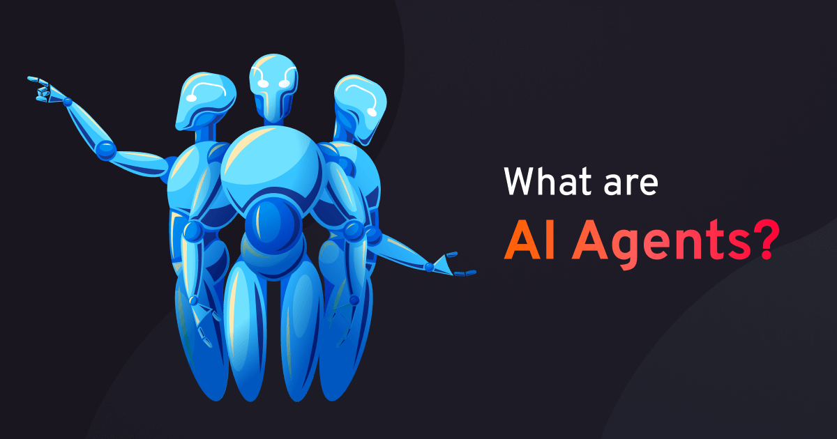

## **🧠 AI-First Development**

### **🔍 Why It Matters**

In the Agentia ecosystem, **AI agents are the cognitive core**—driving autonomy, decision-making, and adaptive behavior across every layer of interaction. By adopting an **AI-first** development approach, DACA ensures that intelligence is not bolted on later, but deeply embedded into the system architecture from the ground up. This enables:

* Natural language understanding and dialogues
* Real-time, context-aware decision-making
* Seamless tool integration
* Dynamic, collaborative workflows between agents

### **⚙️ How It’s Implemented**

DACA operationalizes AI-first principles through a tightly integrated stack:

* **OpenAI Agents SDK** – Handles core agent logic and reasoning capabilities
* **Agent2Agent Protocol (A2A)** – Facilitates peer-to-peer, intelligent communication between agents
* **Model Context Protocol (MCP)** – Standardizes tool and plugin integration, allowing agents to access external capabilities dynamically

This stack enables agents to manage complex, real-world tasks such as coordinating logistics, automating smart environments, or facilitating business processes—all through intelligent, autonomous workflows.

### **🌐 Agentia Alignment**

AI-first development is fundamental to **Agentia’s vision**, where **every entity is an AI agent**—not just communicating via static APIs, but through **fluid, intelligent dialogues**. This shift enables systems that are context-aware, adaptive, and capable of working together to solve intricate, evolving challenges in real-time.

## **🎓 Innovative Teaching Strategy for Agentic AI**

As **Agentic AI rapidly evolves**, educating the next generation of builders requires **strategic, future-ready teaching methods**. This program delivers a carefully structured, hands-on learning path designed to equip beginners with essential skills and gradually guide them into mastering the complex architectures of next-generation AI systems.

### **📚 Teaching Philosophy & Methodology**

Our step-by-step curriculum introduces students to the **foundational tools and concepts of Agentic AI**, starting with:

* **OpenAI’s Responses API**
* **OpenAI Agents SDK**

These accessible tools allow learners to grasp the basics of agent behavior, decision-making, and tool integration. Once core concepts and hands-on capabilities are solidified, students transition to more advanced technologies such as:

* **Cloud-native agent frameworks**
* **Long-running, stateful agents deployed via Docker, Rancher, Kubernetes, and Serverless Containers**

This progressive teaching strategy ensures that students first build conceptual clarity with simple tools—then scale up to architect and deploy sophisticated, real-world systems.

### **🧠 Core Learning Materials to Prepare for the Agentic AI Era:**

To help students understand the social, technical, and economic implications of Agentic AI, we provide curated, engaging resources, including:

* **Agentic AI Explained**
* **AI Agents Explained Like You're 5**
* **AI Is About to FLIP Your Life Upside Down**
* **The Future Is Agentic**
* **The Agent Economy**
* **Why Vertical LLM Agents Are the New $1B SaaS Opportunities**
* **Vertical AI Agents Could Be 10x Bigger Than SaaS**
* **OpenAI’s Path to AGI: Five Levels of Intelligence**
* **AI Agents: Are We Ready for Machines That Make Decisions?**
* **Function Calling**
* **Generative AI’s Act 01**
* **Watch: AGI Could Double GDP**

## **🎯 Why This Program?**

### **🚀 Cutting-Edge Skills**

Gain hands-on experience with the most in-demand tools and frameworks for building **intelligent, scalable Agentic AI Cloud solutions**—from AI-first development to robotics and distributed computing.

### **💼 Industry-Ready in 9 Months**

Become job-ready in under a year. This program prepares you for **global certifications**, **freelance careers**, or **startup ventures** by the end of the third quarter.

### **🔮 Future-Proof Your Career**

Stay ahead in a world being reshaped by Agentic AI, Generative Intelligence, and Cloud-Native infrastructures. Learn the skills that will define the **next decade of innovation**.

## **📘 What You’ll Learn**

### **🤖 Multi-Agent AI Systems**

Learn how to design and coordinate teams of AI agents that perform **complex, multi-step tasks** using OpenAI’s Responses API and Agents SDK. Build **knowledge graphs**, and apply these systems to **automate real-world business processes**.

### **🌐 Distributed System Design**

Understand the architecture of systems that run across **multiple nodes or devices**, collaborating and coordinating actions in **real time**. Build resilient, scalable applications on **cloud-native infrastructure**.

### **🎨 AI Solution Design with Design Thinking & BDD**

Master **Design Thinking** and **Behavior-Driven Development (BDD)** to craft AI systems that are not just functional, but **deeply aligned with human needs** and contextually intelligent.

### **🧠 Fine-Tuning Open-Source LLMs with PyTorch**

Dive deep into **LLM customization** using frameworks like **PyTorch**. Learn to fine-tune powerful open-source models such as **Meta LLaMA 3** for domain-specific tasks and applications.

### **🧩 Comparison of Top Agentic AI Frameworks in Python**

This visual matrix provides a side-by-side comparison of the **leading Agentic AI frameworks in Python**, including LangGraph, CrewAI, Autogen, MetaGPT, AgentVerse, and others. It evaluates each framework based on four key dimensions: **ecosystem/history**, **use cases**, **core strengths**, and **design limitations**. The chart highlights frameworks that excel in building multi-agent systems, long-term memory integration, tool orchestration, and autonomous task execution. It also surfaces trade-offs such as limited scalability, steep learning curves, or poor integration with cloud infrastructure. This comparison is essential for AI engineers, researchers, and developers looking to select the most suitable platform for building scalable, intelligent agent systems in real-world applications.

| **Framework / Library** | **Ecosystem / History** | **Use Cases** | **Pros** | **Design Weakness** |
| --- | --- | --- | --- | --- |
| **LangGraph (built on LangChain)** | LangChain ecosystem | Multi-agent workflows, stateful agents | ✅ Based natively in LLMs  ✅ Strong OpenAI integration  ✅ Visual graph planning | ❌ LangChain dependency  ❌ Steeper learning curve than others |
| **CrewAI** | Community-built | Multi-agent execution  Role-based teamwork | ✅ Fast adoption  ✅ Simple role/goal setup  ✅ Popular for projects | ❌ No native memory support  ❌ Lacks persistence or state |
| **Autogen (by Microsoft)** | Backed by Microsoft | Multi-agent chat systems  LLM + tools + human | ✅ Human-AI teaming  ✅ Rich function calling  ✅ LLM tool chaining | ❌ Complex thread setup  ❌ Not cloud-native |
| **MetaGPT** | China, open-source | Code writing agents  Team simulation | ✅ Project-based  ✅ Good for dev workflows | ❌ Rigid thread model  ❌ Limited flexibility |
| **Superagent** | Open-source startup | Multi-agent workflows  API orchestration | ✅ No-code UI  ✅ Agent memory  ✅ Realtime dashboards | ❌ Memory leaks  ❌ Not production-ready |
| **LangChain Agents** | LangChain ecosystem | Tool-using agents  Single/multi-step | ✅ Many tools  ✅ Good OpenAI & Google support | ❌ Memory limitations  ❌ Difficult for chaining |
| **AgentVerse** | Lightweight open-source | Customizable agents  Multi-agent arenas | ✅ Easy to fork  ✅ Lightweight | ❌ Minimal library support  ❌ Not enterprise-ready |
| **AiAgents (by Farama)** | Research-first | Planning & navigation | ✅ Research-focused  ✅ Works with gym/envs | ❌ Tool integration weak  ❌ Not for general use |
| **PromptLayer Agents** | Built on PromptLayer | Simple orchestrations  Dev-focused | ✅ Logging  ✅ Debugging | ❌ Small community  ❌ Not open-source |

### **🧠 Elevating AI Education: Python Decorators for Agentic AI Engineering**

This shared lesson introduces learners to the powerful concept of **Python decorators**, a foundational tool in AI engineering for extending functionality, improving modularity, and enabling sophisticated behaviors like logging, timing, access control, and caching. Framed within the context of **Agentic AI development**, the lecture blends clear explanations with hands-on examples—demonstrating how decorators can be used to enhance AI inference workflows and system performance. It’s an essential starting point for students aiming to master Python's advanced features while building intelligent, scalable agent systems.

<https://chatgpt.com/share/68860931-da10-8003-a2d0-7d9e5085fb80>

### **🛠️ GitHub Repository: Advanced Agentic AI**

This GitHub repository — [**Advance-Agentic-AI**](https://github.com/BIGGOOO/Advance-Agentic-AI) — is a practical, open-source resource focused on building next-generation **Agentic AI systems**. It offers real-world implementations of multi-agent collaboration, autonomous tool use, and cloud-native deployment strategies. The repo aligns with cutting-edge frameworks like **LangGraph**, **CrewAI**, and **AutoGen**, and includes code samples, structured agent flows, and deployment-ready scripts designed to help developers, researchers, and learners explore the future of AI-first architecture. Ideal for those pursuing projects in **autonomous agents**, **AI infrastructure**, or **intelligent automation**.

### **📒 Google NotebookLM: Agentic AI Learning Companion**

This [**NotebookLM resource**](https://notebooklm.google.com/notebook/c31e553e-d6a3-420c-b5b7-e6eb26affb2a) serves as an **interactive learning companion** for exploring the evolving world of **Agentic AI**. Curated with structured notes, summaries, and references, it supports learners in understanding complex topics such as **multi-agent systems**, **AI frameworks**, **cloud-native deployment**, and **humanoid robotics**. Leveraging Google's powerful language model, the notebook allows you to **ask questions, cross-reference sources**, and **generate insights** directly from your study materials—making it a smart, AI-powered guide for students, developers, and AI enthusiasts alike.

Listen Podcast on Agentic AI : <https://notebooklm.google.com/notebook/c31e553e-d6a3-420c-b5b7-e6eb26affb2a/audio>